**Proposed Implementation**

End Users：Agricultural Lands in Southern China

Our project hopes to inoculate the engineered bacteria into earthworms, and apply these earthworms to the farmland in southern China before the crops are planted in each season. The aim is to protect the agricultural soil from deteriorating associated with lead pollution.

There are two reasons why the target agricultural lands are chosen in southern China.

First of all , in 2018, the Chinese government issued the soil risk control standards for agricultural lands, in which the quality and safety of edible agricultural products were taken as the standard to set the screening value and control value of soil pollution risk in agricultural land. When the lead content of cultivated land exceeds the screening value, the quality and safety of agricultural products may be at risk, while the risk is higher when the lead content exceeds the control value. Survey data shows that lead pollution widely spreads in agricultural lands in China, and the lead concentration in polluted agricultural lands is mostly in the range above the screened value and the highest near the controlled value.

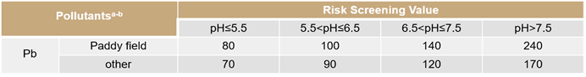

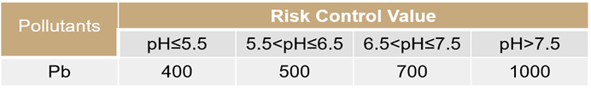

Secondly, *Eisenia Fetida* is widely used as Vermicomposting earthworm species, and it also shows good heavy metal tolerance in heavy metal contaminated sites，which ensures the normal growth of our earthworms and have a certain effect on the treatment of lead pollution in the soil at the same time.

Application in the Real World

We imagine that when our project is applied in the real world, a closed loop can be formed between the laboratory, biotechnology and farm to promote mutual improvement. After obtaining the engineered bacteria in the laboratory, we will register them for patents and sell them to biotechnologies and provide certain technical support. The biotechnologies will carry out further screening, expansion and freeze-drying preservation. Wash the artificially cultivated earthworms and put them in a turnover box with moist absorbent paper. Add the freeze-dried powder of engineered bacteria. Take out and wash them after one day, and sell them to farmers, while providing a certain assessment of heavy metal pollution in farmland. Before planting each season, farmers inoculate earthworms in the farmland with an amount of 60g/m <sup>2 and supplement the inoculation according to the changes in the number of earthworms. At the same time, providing some real application feedback for the laboratory to make technical improvements.(此图美工在改)



Future Applications

* Used in Vermicomposting.

Earthworms eat a lot of manure and take advantage of the synergy of intestinal microbes. They can efficiently transform organic matter and accelerate fertilizer maturity. However, the lead in “farm manure” is also an important source of lead pollution on farmland. If earthworms inoculated with engineered bacteria are applied to Vermicomposting, they will greatly reduce the lead pollution in fertilizers entering the soil and avoid the use of chemical fertilizers, which will promote the development of Vermicomposting and contribute to the sustainable agriculture.

* Multi-functional application

After the engineered bacteria have made progress in the treatment of lead pollution, we will design other recombinase to obtain free dissociative sulfur and phosphate groups to deal with other heavy metal pollution.

* Sustainable application.

After fully verifying the safety and security of the project, we plan to release the engineered bacteria directly into the soil environment to ensure their role in every generation, which will greatly reduce the cost of project implementation.

Safety

Due to the epidemic, we cannot enter the laboratory for experiments this year, and we attach great importance to safety work. We studied lectures and regulations related to safety and ethics to ensure the safety of all parts of our project at the start.

**Security of project design**

* Overall biosafety

Our project envisages using *Bacillus subtilis* WB800N as the chassis organism, *Bacillus subtilis* YCD as the source of phytase, and Eisenia vulgaris as the engineering bacteria carrier. *Bacillus subtilis* is a safe and commonly used strain in laboratories, and usually does not cause obvious risks to human health, the community or the environment. *Eisenia Fetida* is a widespread species in China and is widely used as a compost species in southern China. And our project will not release engineered bacteria and earthworms into the environment. Therefore, our project is very safe.

* Gene safety

We designed a suicide switch in the gene pathway to initiate suicide when the engineered bacteria enter the environment, avoiding the risk of gene drift to the greatest extent.

**Implement security**

When we envision our project to play a role in the soil environment in the real world, we will follow the principle of gradual evaluation, gradually increasing the release scale. We will evaluate each step of the implementation and reasonably optimize the implementation plan.

**Laboratory safety**

We will not enter the laboratory to conduct experiments, but we still have received laboratory safety training and passed the laboratory safety exam. We are familiar with laboratory safety operations and emergency measures.

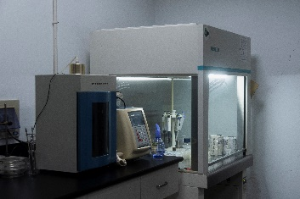 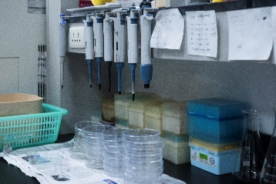 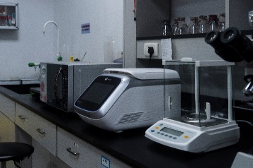

PDF链接

**Challenge**

* How to ensure the activity of earthworms and engineered bacteria？

Soil animals are sensitive to the toxicity of pesticides. Long-term use of pesticides has a great impact on the types, quantity, flora and respiratory intensity of soil animals. Relevant studies have shown that pesticide pollution will lead to the decline of soil microbial functional diversity, and also reduce the use of carbon substrates by microorganisms. Therefore, the use of pesticides and chemical fertilizers on farmland may cause problems, for example, low activity of earthworms or engineered bacteria.

However, the development of earthworm composting technology can improve the utilization efficiency of nutrients in organic fertilizer by plants. Therefore, if follow-up research can give full play to the synergistic effects of Vermicomposting and beneficial microorganisms, the use of pesticides and chemical fertilizers can be greatly reduced.

* Wrong suicide

In addition, When the biological company feeds the freeze-dried powder to earthworms, the engineered bacteria can be recovered in the turnover box, which will lead to abnormal suicide of the engineered bacteria.

This kind of wrong suicide requires two conditions. One is the leakage of the promoter that controls the expression of trigger RNA. The other is the recovery of the engineered bacteria in the turnover box. However, the relatively dry environment in the turnover box is not conducive to the recovery of the engineered bacteria. Therefore, the possibility of wrong suicide is very low, and the loss caused is small as well.

References:

[1] Zhang W X，Shen Z F，Shao Y H，Shi L L，Liu S J，Shi N N，Fu S L．Soil biota and sustainable agriculture: A review． Acta Ecologica Sinica，2020，40 ( 10) : 3183-3206．

[2] Xu Qin. An overview of the geographical distribution of terrestrial earthworms in China[J]. Journal of Beijing Institute of Education, 1996(03): 54-61.